**Problem Statement**

Holcim Ltd. needs to make delivers for the day. The orders that need to be delivered are listed in the Sheet “Sample Order”. Metadata **b**elow.

|  |  |
| --- | --- |
| Column | Description |
| Order ID | Unique Code associated with the Order |
| Plant | Manufacturing Plant from where delivery needs to start |
| Destination | City where order is delivered |
| Qty (KG) | Qty of Cement to deliver |

Sheet “Transporter Cost” contains freight information for each of transporter for source destination pair. Metadata **b**elow.

|  |  |
| --- | --- |
| Column | Description |
| Transporter | Name of Transporter (Company) that owns fleet of trucks |
| Plant | Manufacturing Plant from where delivery needs to start |
| Destination | City where order is delivered |
| Cost per kg | Cost of delivering 1kg of Cement from Plant to Destination |

Create a one page application that takes **number of trucks available** with each transporter as input and gives the combination of transporter and trucks with minimum transportation Cost as the output.

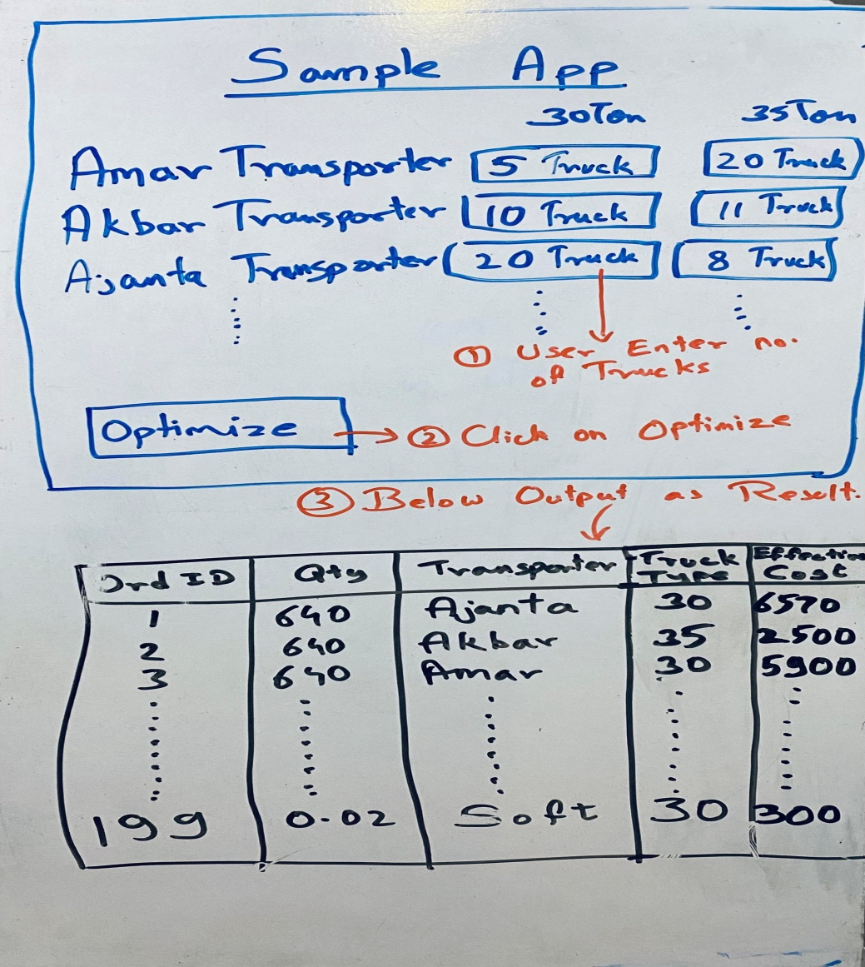

**Important Information:**

1. Every transporter has 2 types of trucks i.e. 30 Ton and 35 Ton
2. Each truck can **b**e sent to only one location. Multi-location delivery is not allowed.
3. If partially filled truck is sent for delivery, the transporter is paid full cost of the truck i.e. if we send 30 ton truck filled with only 15 Ton Cement, the transporter has to **b**e paid for all 30 tons.
4. Transporter detail is missing for any Plant-Destination pair implies that transporter is not eligible to do deliveries in that route.

**\*Prioritize Algorithm over application**

**\*Application can be built on any framework**

**\*Algorithm should be built in Python**